

OCTOBER 2020
I, the undersigned, as parent/guardian of ……………………. duly declare that to the best of my knowledge, the above player is free from COVID-19 symptoms (Fever, cough, difficulty breathing, body aches, sore throat, fatigue, nausea/vomiting/diarrhoea and/or loss of smell or taste within the last 7 days)
I give my consent for hygiene and safety protocols to be carried out by the trained coaching team prior to commencing a coaching session.
My son/daughter has not knowingly been in contact with any person who has contracted COVID-19 or is showing symptoms thereof.
If, in the course of time, it comes to light that the player concerned unknowingly had contact with an infected person, I shall inform The Complete Cricketer Academy immediately.
Signed: ………………………..………………… (Parent/Guardian)
Date: …………..…………2020.


and The Complete Cricket Academy have partnered to ensure the health and safety of all participants associated with the usage of the Montague Gardens facility during Covid-19 times.
- All products provided by Dromex for usage are EN and SABS approved products.
- Should any participant, parents or anyone related to the above enterprise have any questions they are welcome to contact Mr Ward directly or any member of the Dromex team. NICO LOIZIDES REGIONAL MANAGER T. +27(0)21 224 0935
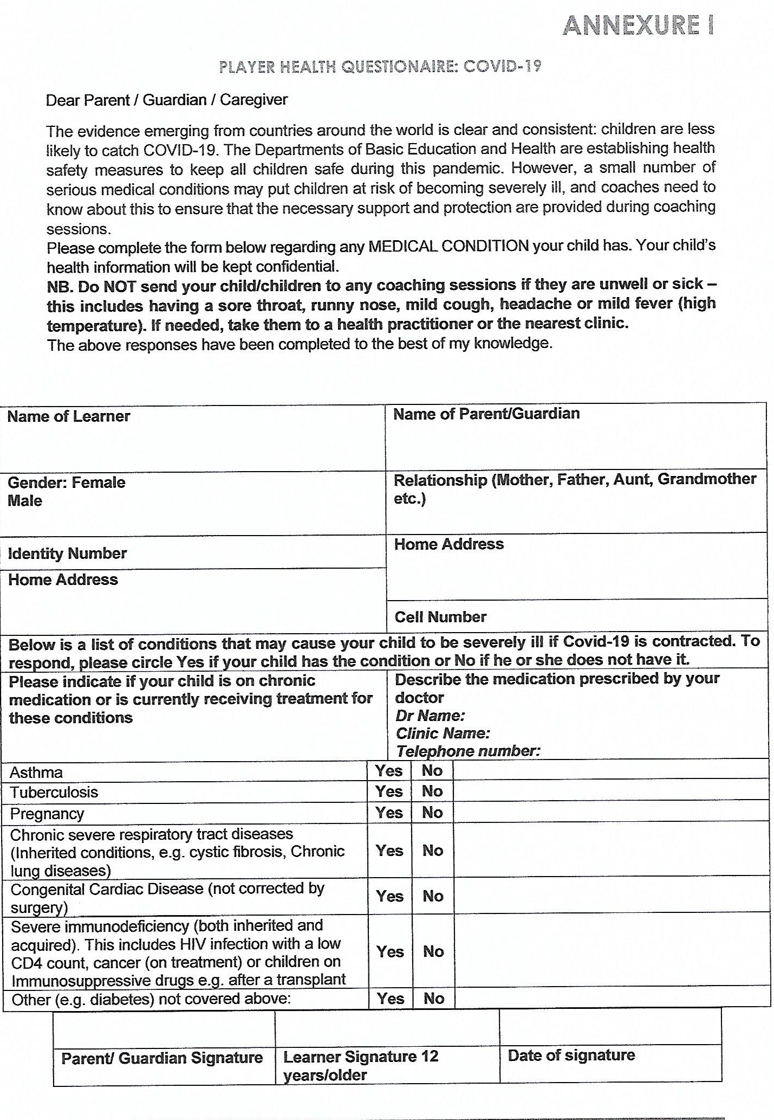
i
[Grab your reader’s attention with a great quote from the document or use this space to emphasize a key point. To place this text box anywhere on the page, just drag it.]

Michelle DMiD

THE COMPLETE CRICKETER ACADEMY REGISTRATION AND CONSENT FORM
PLAYER INFORMATION

Surname: | Home Tel:
First Name: | Cell #:
Date of birth: | Parents Name:
School: | Parents ID #:
Grade: | Email:

Disability
Do you consider yourself to have a disability? Yes/No
Visual Impairment | Hearing Impairment | Physical Disability
Learning Disability | Multiple Disability | Other (please specify)

Family GP: ..…………………………. Phone: ……………………………………….

Pre-existing medical conditions (e.g. allergies or chronic illnesses)
………………………………………………………………………………………………

Other(s) to contact in case of emergency:…………………………………………….
Relationship to child: ………………………… Contact number: …………………….

Sporting Information
Have you played cricket before? Yes/No
If yes, where have you played the sport?

School | Club Name
Local Coach/Name | Provincial/National representation: Y/N
Other

INFORMED CONSENT FORM
I hereby give my permission for …………………...…………….. to participate in cricket coaching sessions at Montague Gardens Action Cricket Arena under supervision of the trained staff of "The Complete Cricketer Academy"

Further, I authorise the Academy to provide emergency treatment of an injury to, or illness of my child if qualified medical personnel consider treatment necessary and perform the treatment. This authorisation is granted only if I cannot be reached and reasonable effort has been made to contact me.

My child and I are aware that participating in cricket coaching sessions is a potentially hazardous activity. I assume all risks associated with participation in this sport, including but not limited to falls, contact with other participants, contact with cricket balls and other equipment, and other reasonable-risk conditions
associated with the sport. All such risks to my child are known and understood by me.

I understand this informed consent form and agree to its conditions on behalf of my child.

I, the undersigned, Parent/Legal guardian of________________________
hereby indemnify and hold harmless, The Complete Cricketer Academy, Montague Gardens Indoor Arena and their employees for any loss, damage or injury during the sessions.

Signed:______________________________Date: __________________

Player Protocols prior to resuming coaching.
These protocols have been set by CSA/WPCA to allow training. We have to strictly abide by them or we could be closed down. They are in place to maximise health and safety for all players and coaches.
- Players will be required to wear their own mask for entry and when within closer social distancing ranges but can bat/and or bowl without a mask, as long as correct distancing is maintained. NO MASK, NO ENTRY
- Players should arrive ready for training and avoid use of communal/changing areas where possible. “Get in, Train, Get out”

- Each player will be required to bring their own kit and own cool drink (NO SHARING ALLOWED).

- Every player will be required to have their temperature recorded with an infrared thermometer before the session, answer three C-19 related questions and have their hands and the bottom of their shoes sanitized.

- Parents will not be able to attend sessions and should remain outside of the training area for the duration of the session.

